1. There should be 2 separated ‘urls.py’ files created under:

* Project folder
* Application folder (no default – have to be created)

**Application folder:** urls.py file should contain imported functions from views.py (except index function and admin interface), mapped to r’^$’:

→ url(r'^$', views.users, name='users'),

**Project folder:** urlpatterns from app folder urls.py file should be implemented in urlpatterns in project folder using include(…) function (map to: r’^*address*/’) . Basically included function will redirect to app/urls.py to give the next piece of url for users/:

→ url(r'^users/', include('AppTwo.urls')),

2. Make migrations:

python manage.py migrate

3. Template tagging:

<!-- basicapp refers to app/urls.py app_name varable value; other refers to mapping name for other.html template -->  
<a href="{% url 'basicapp:other' %}">OTHER PAGE</a>  
<a href="{% url 'admin:index' %}">LINK TO ADMIN</a>  
<!-- just redirecting to index -->  
<a href="{% url 'index' %}">LINK TO INDEX</a>

4. Template inheritance:

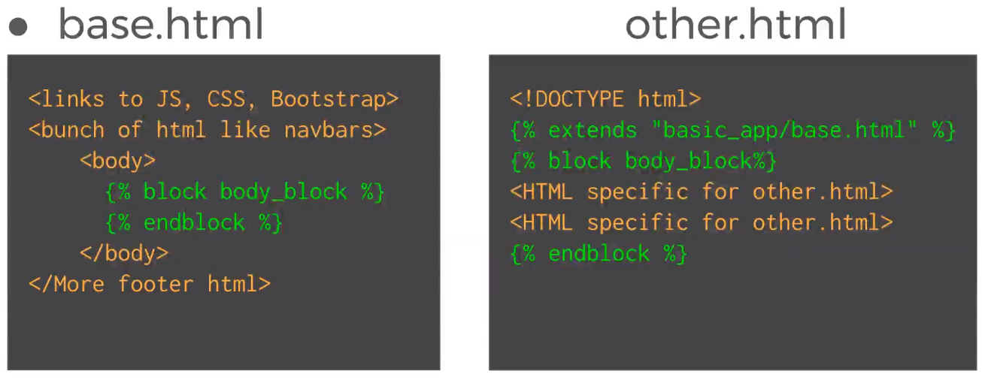

5. Template filters

- Operations on variables → {{ }} / passed as context dictionary in app/views.py

a) App level

- New directory → templatetags

- Add empty „__init__.py” file

b) Create new .py file and write own filters